MPM 2D Handout
Solving Linear Systems of Equations by Graphing
Date: Name:

- Graph each of the following lines by writing its equation in y = mx + b form.


  - 2y = -3x + 6

  - 3x – y = 2

  - 2x + 3y = 9

- Find the x and y intercepts for each of the following lines.
  - 2x – 6y = 12 b. -3x + 4y = -6 c. ½ x = -2y + 5

- Graph each line from question 2 using the intercepts.
- Solve each of the following systems of linear equations by graphing.
  - $y=-2x+1$ b. $\frac{2}{3}x-y=-1$
$2x+4y=-8$ $-x+3y=4$

- The graph provided shows a linear system of equations.
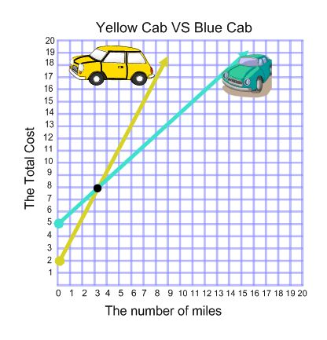
  - State the solution.

  - Use the axes to interpret the solution and write a concluding statement.

- A train departs from Windsor and travels to Toronto at an average speed of 120 kmh. At the same time, a train departs from Toronto and travels to Windsor at an average speed of 100 km/h. Assume that Windsor and Toronto are exactly 400 km apart.
  - Create two equations (one for each train) to model the situation. Be sure to define your variables.

  - Graph both lines on the grid provided.



  - Use your graph to approximate the time and distance from Windsor when the trains pass each other.

